
Förbättringsområden: Åtgärdsplan:
1.
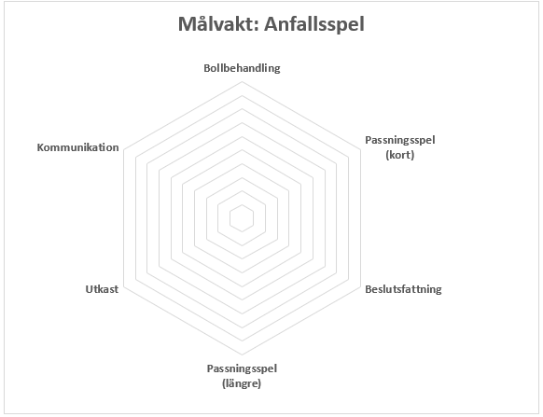
____________________________________________________________ ________________________________________________________________
2.

____________________________________________________________ ________________________________________________________________
3.

____________________________________________________________ ________________________________________________________________
